[MIT’s lithium-metal battery could change the world](https://www.element14.com/community/groups/power-management/blog/2020/10/02/mit-s-lithium-metal-battery-could-change-the-world)

Posted by [Cabe Atwell](https://www.element14.com/community/people/Catwell) in [Power & Energy](https://www.element14.com/community/groups/power-management/blog) on Oct 2, 2020 1:33:00 PM

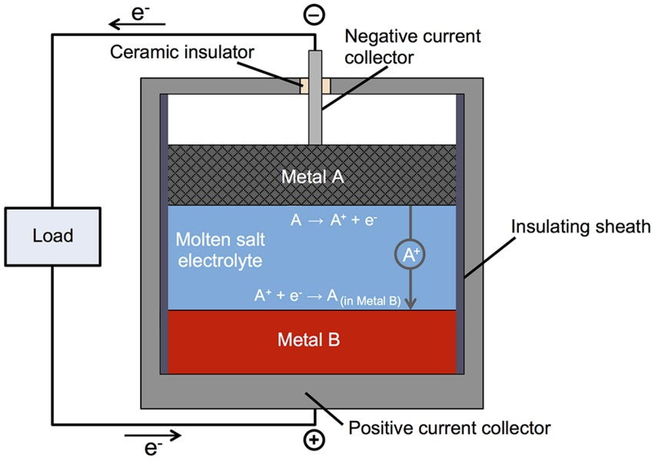

**This liquid metal battery could replace lithium-ion batteries to provide power to hospitals, manufacturing facilities or a subdivision of several hundred homes. (Image Credit: MIT)**

The problem with intermittency in non-fossil fuel electricity generation must be addressed before shifting towards a fully renewable energy-based economy. To help solve this issue, Donald Sadoway and his team at MIT developed a [liquid metal battery](https://www.element14.com/community/external-link.jspa?url=https%3A%2F%2Fnews.mit.edu%2F2016%2Fbattery-molten-metals-0112) that can be used for stationary energy storage. The goal was to create an affordable liquid metal battery for consumers. It has potential to power hospitals, manufacturing facilities or a subdivision of several hundred homes.

Similar to a traditional battery, this contains top and bottom electrodes with an electrolyte in the middle of them. As it’s recharging and discharging, positively charged metallic ions transfer from one electrode to the other through the electrolyte. An external circuit also moves the electrons. The majority of batteries have solid electrodes and sometimes the electrolyte. However, in this liquid-metal battery, all three of those are liquid. The top layer, which is the negative electrode in the battery, is a low-density liquid metal that sends out electrons. The bottom layer is a high density liquid that takes in those electrons. Finally, the molten salt electrolyte layer is in the middle and its role is to move charged particles without mixing with the materials from above or below. Since there are differences in density along with the immiscibility of the materials, they are able to naturally settle into three layers, staying separate while the battery is functioning.

This technique provides a number of benefits. Since it uses liquid materials, the transfer of electrical charges and chemical constituents within each material and from one to another is extremely fast. This allows large currents to flow rapidly into and out of the battery. While discharging, the molten metal layer thins while the bottom layer thickens. As it’s charging, the thicknesses reverse. Even though solid electrodes can crack and undergo mechanical failure over time, liquid electrodes do not degrade.

When the battery has been charged, ions that were deposited in the bottom layer are sent back to the top, purifying the electrolyte. Another benefit is that membranes or separators aren’t needed because the components naturally self-segregate. This liquid battery can be charged and discharged many times without capacity loss or needing maintenance. Additionally, the self-segregating nature of the components could allow these batteries to be manufactured at a low-cost compared to traditional ones.

In order to keep the costs down, electrode materials that were long-lasting, inexpensive, and environmentally friendly were used in the batteries. A high voltage was created by pairing a tough electron donor with a strong electron acceptor. The electron donor needed to be low density while the electron acceptor had to be high density. Then, the materials needed to be liquid at a proficient temperature.

The top electrode antimony contains magnesium and the bottom layer has a salt mixture that contains magnesium chloride for the electrolyte. These liquid components self-segregated, and the battery operated as expected.

Donald Sadoway, chemistry professor at MIT, believes lithium-metal batteries could replace lithium-ion batteries in the future. While they have a longer lifetime, liquid-metal is capable of operating at large scale safely without any fire risks, and it’s inexpensive to manufacture, making it a suitable replacement.

Transitioning to a carbon-free economy has to come from the private sector and from newer technologies and inventions that outperform today’s power generating methods.

Sadoway also says there are various combinations on the positive electrode, including nickel oxide, cobalt oxide, manganese oxide, and aluminum oxide. People also want to eliminate cobalt and get it down as low as possible. However, there is a larger demand for nickel.

Have a story tip? Message me at: cabe(at)element14(dot)com

[http://twitter.com/Cabe_Atwell](https://www.element14.com/community/external-link.jspa?url=http%3A%2F%2Ftwitter.com%2FCabe_Atwell)

* 9887 Views
* Tags: [power](https://www.element14.com/community/groups/power-management/blog/tags#/?tags=power), [innovation](https://www.element14.com/community/groups/power-management/blog/tags#/?tags=innovation), [battery](https://www.element14.com/community/groups/power-management/blog/tags#/?tags=battery), [university](https://www.element14.com/community/groups/power-management/blog/tags#/?tags=university), [mit](https://www.element14.com/community/groups/power-management/blog/tags#/?tags=mit), [on_campus](https://www.element14.com/community/groups/power-management/blog/tags#/?tags=on_campus), [cabeatwell](https://www.element14.com/community/groups/power-management/blog/tags#/?tags=cabeatwell)